ECE 461/561 Project 3 Report Template

Date

Your Name and Unity Email Address **Abhishek Ravi aravi6@ncsu.edu**

Your Partner’s Name and Unity Email Address **Siddharth Ganesh sganesh6@ncsu.edu**

# Summary

Table showing execution time at each stage, and brief description of optimizations applied, for example:

|  |  |  |
| --- | --- | --- |
| Stage | Brief Description of Optimizations | Execution time |
| Base Code | Compiler settings **Level 3(-03); misc controls: --fpmode=fast** | 197ms |
| Optimization 1 | **defined constant values for pi/180 and 180/pi** | 194ms |
| Optimization 2 | **used sin_32, cos_32 and asinf and sqrtf** | 107ms |
| Optimization 3 | **reducing precision of pi and other pi dependent variable; reduced precision of cos_32 constants** | 100ms |
| Optimization 4 | **changed the Drift_Calculation file where we use the temp variable. As we know asin(1) and asin(-1) is 90 and -90, respectively , we simplified the calculation for certain conditions(temp > 1 or temp <-1). We also forced certain constants as floating values by adding f at the end of the value.** | 83.48ms |
| Optimization 5 | **use of ternary operator ?: to check range of local_angle_current instead of if-else loop.** | 83.45ms |
| Optimization 6 | **forced all double variables to float in trig_approx.c file** | 72.25 ms |

# Base Code

Compiler settings **Level 3(-03); misc controls: --fpmode=fast**

Total execution time **197 ms; 3062 samples**

Table showing the five functions which take most of the program’s time, for example:

|  |  |  |
| --- | --- | --- |
| Function Name | Number of Samples | % of Program Execution Time |
| _dmul | 907 | 29.62 |
| _dsub1 | 227 | 7.41 |
| _ll_udiv10 | 171 | 5.58 |
| _fsub | 166 | 5.42 |
| Isspace | 131 | 4.27 |

# Optimization 1

Description of optimizations performed **defined constant values for pi/180 and 180/pi**

Total execution time **194 ms; 2995 samples**

Table showing the five functions which take most of the program’s time, for example:

|  |  |  |
| --- | --- | --- |
| Function Name | Number of Samples | % of Program Execution Time |
| _dmul | 906 | 30.25 |
| _fsub | 301 | 10.05 |
| _dsub1 | 202 | 6.74 |
| _ll_udiv10 | 198 | 6.61 |
| Get_Data | 192 | 6.41 |

# Optimization 2

Description of optimizations performed **used sin_32, cos_32 and asinf and sqrtf**

Total execution time **107 ms ; 1701 samples**

Table showing the five functions which take most of the program’s time, for example:

|  |  |  |
| --- | --- | --- |
| Function Name | Number of Samples | % of Program Execution Time |
| __vfscanf | 388 | 22.8 |
| _dmul | 294 | 17.28 |
| frexp | 102 | 5.99 |
| fputc | 101 | 5.93 |
| __ieee754_rem_pio2 | 100 | 5.87 |

# Optimization 3

Description of optimizations performed **reducing precision of pi and other pi dependent variable; reduced precision of cos_32 constants**

Total execution time **100ms; 1814 samples**

Table showing the five functions which take most of the program’s time, for example:

|  |  |  |
| --- | --- | --- |
| Function Name | Number of Samples | % of Program Execution Time |
| _ieee754_rem_pio2 | 1038 | 57.22 |
| _fp_value | 154 | 8.48 |
| _dsub1 | 99 | 5.45 |
| _scanf_really_hex_real | 78 | 4.29 |
| _ddiv | 75 | 4.13 |

# Optimization 4

Description of optimizations performed **changed the Drift_Calculation file where we use the temp variable. As we know asin(1) and asin(-1) is 90 and -90, respectively , we simplified the calculation for certain conditions(temp > 1 or temp <-1). We also forced certain constants as floating values by adding f at the end of the value.**

Total execution time **83.48ms, 1395 samples**

Table showing the five functions which take most of the program’s time, for example:

|  |  |  |
| --- | --- | --- |
| Function Name | Number of Samples | % of Program Execution Time |
| __ieee754_rem_pio2 | 794 | 56.91 |
| _fp_value | 296 | 21.21 |
| _dsub1 | 100 | 7.16 |
| __user_setup_stackheap | 99 | 7.09 |
| _scanf_really_hex_real | 5 | 0.358 |

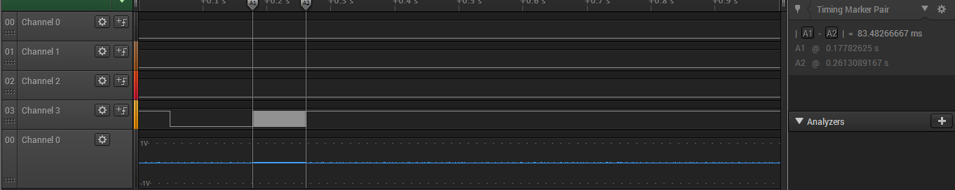

# Optimization 5

Description of optimizations performed **use of ternary operator ?: to check range of local_angle_current instead of if-else loop.**

Total execution time **83.45ms, 1255 samples**

Table showing the five functions which take most of the program’s time, for example:

|  |  |  |
| --- | --- | --- |
| Function Name | Number of Samples | % of Program Execution Time |
| __ieee754_rem_pio2 | 557 | 44.38 |
| _fp_value | 163 | 12.98 |
| _dadd1 | 118 | 9.40 |
| _dsub1 | 100 | 7.96 |
| scanf_really_hex_real | 61 | 4.86 |

# Optimization 6

Description of optimizations performed **forced all double variables to float in trig_approx.c file**

Total execution time **72.25 ms ; 1401 ssamples**

Table showing the five functions which take most of the program’s time, for example:

|  |  |  |
| --- | --- | --- |
| Function Name | Number of Samples | % of Program Execution Time |
| _fmul | 303 | 21.62 |
| _fdiv | 279 | 19.91 |
| _fsub | 202 | 14.41 |
| Compute_current | 194 | 13.84 |
| _fsqrt | 108 | 7.70 |